HOTEL BOOKING WEBSITE
@CREATIVITY THINK (9483175986/7019689991)

ABSTRACT:
The Hotel Booking Website is a web-based platform designed to simplify hotel reservations for users while providing administrators with powerful management tools. Users can search for hotels, filter rooms, book accommodations, make payments, and view booking history. Administrators manage hotel listings, room availability, reviews, and generate sales analytics. Built with Django and Django Rest Framework for backend operations and React with Axios and Leaflet for frontend visualization, the system ensures seamless user experiences, real-time availability updates, and comprehensive analytics. This platform enhances efficiency for travel agencies, hospitality businesses, and online travel portals..

INTRODUCTION OF THE PROJECT:
Booking hotels online requires an efficient, interactive, and reliable system to handle multiple users, room availability, payments, and reviews. The Hotel Booking Website offers users an intuitive interface to search and filter hotels, make bookings, and view past reservations. Administrators can manage hotel listings, monitor room availability, handle reviews, and analyze sales through dashboards. Using Django for backend logic and React with Axios and Leaflet for frontend mapping and interactivity, the platform provides a responsive, real-time system that ensures smooth booking experiences and operational efficiency for hospitality businesses..

PROJECT OBJECTIVES:

• Develop a user-friendly web platform for hotel bookings
• Enable users to search, filter, and book hotel rooms efficiently
• Facilitate secure online payment processing
• Allow users to view booking history and submit reviews
• Provide administrators with tools to manage hotels and room availability
• Generate analytics for sales, bookings, and customer feedback
• Improve operational efficiency for hospitality providers

PROBLEM OF THE STATEMENT:
Travelers and customers often face difficulties with manual hotel bookings, limited visibility of room availability, and delayed confirmation. Traditional methods lack real-time updates, making it hard for users to plan their stays efficiently. Administrators struggle to manage multiple hotel listings, optimize room availability, handle reviews, and analyze booking data efficiently. The Hotel Booking Website solves these challenges by providing a centralized, real-time platform for searching, booking, and reviewing hotels. The system offers administrators powerful tools for hotel management, room optimization, review handling, and sales analytics, improving operational efficiency and user satisfaction..

MOTIVATION OF THE PROJECT:
• Improve user convenience in booking hotels online
• Provide real-time room availability and booking confirmation
• Reduce errors in manual booking systems
• Offer administrators analytics and control over hotel operations
• Enhance customer engagement through reviews and past booking tracking

BLOCK DAIGRAM OF PROJECT:

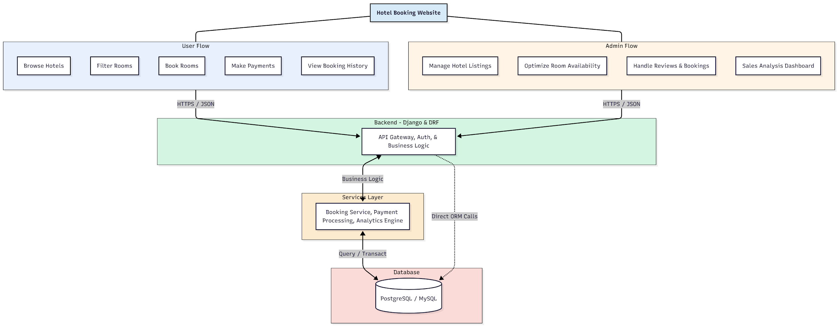

WORKING OF THE PROJECT:
Users log in to the Hotel Booking Website to search and filter hotels based on location, availability, and price. They can book rooms and make payments securely, while past bookings and reviews are stored for reference. The backend handles authentication, booking logic, and API requests, while services manage payment processing, analytics, and room availability. Administrators oversee hotel listings, optimize room allocation, manage reviews, and analyze booking trends through dashboards. This integrated system ensures seamless hotel booking, efficient administration, and actionable business insights..

SOFTWARE REQUIREMENT:
- Backend:
  - Python 3.x
  - Django
  - Django REST Framework
  - SQLite/PostgreSQL
- Frontend:
  - Node.js and npm
  - React.js
  - Axios
- Development Tools:
  - Visual Studio Code
  - Postman (for testing APIs)
  - Git/GitHub (for version control)
- Server/Deployment (Optional):
  - Gunicorn, Nginx, or Heroku/AWS for hosting

ADVANTAGES OF THE PROJECT:

• Real-time hotel search and booking
• Filter rooms based on preferences
• Secure online payment processing
• Track booking history and user reviews
• Optimize room availability for administrators
• Dashboard analytics for sales and performance
• Reduce manual errors in booking and management
• Improve user experience and operational efficiency

APPLICATIONS OF THE PROJECT:
• Travel agencies and tour operators
• Hospitality management systems
• Online hotel booking portals
• Corporate booking and travel management
• Vacation rental and resort management
• Customer review tracking systems
• Payment and booking history management
• Analytics-driven decision-making for hotel businesses

REFERENCES:

- Django REST Framework Documentation — Django Software Foundation. Django Documentation. Available: https://docs.djangoproject.com/
- Django REST Framework. DRF Documentation. Available: https://www.django-rest-framework.org/
- React. React Official Documentation. Available: https://reactjs.org/docs/getting-started.html
- Redux. Redux Documentation. Available: https://redux.js.org/introduction/getting-started
- PostgreSQL Global Development Group. PostgreSQL Documentation. Available: https://www.postgresql.org/docs/
- MySQL. MySQL Reference Manual. Available: https://dev.mysql.com/doc/
- Git. Git Documentation. Available: https://git-scm.com/doc
- Node.js. Node.js Documentation. Available: https://nodejs.org/en/docs/
- Axios. Axios Documentation. Available: https://axios-http.com/docs/intro
- Socket.io Documentation – https://socket.io/docs/

